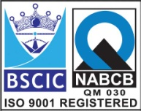****

**“EASCO” PTFE Lined Butterfly Valve Pneumatic Operated**

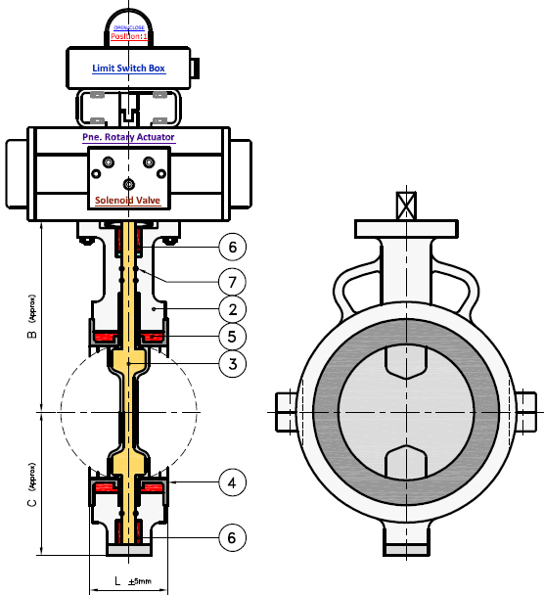

**Features: -**

* Temp: Up to 200 C (PFA Lining)
* Temp: Up to 160 C (FEP Lining)
* Lining Thickness : Minimum 3mm all Parts
* Smooth Operation & Installation
* Long Life

**Testing Standard:**

|  |  |
| --- | --- |
| Test Pressure in PSIG | |
| Test | Hydrostatic  ASA150# |
| Pr. Rating |
| Body | 10 |
| Seat | 9.8 |

**Part List: - Standard Dimension (150#): -**

|  |  |  |  |  |  |  |  |  |  |  |  |  |  |
| --- | --- | --- | --- | --- | --- | --- | --- | --- | --- | --- | --- | --- | --- |
| **No.** | **Part Name** | **Materials** |  | **Size** | **50** | **65** | **80** | **100** | **125** | **150** | **200** | **250** | **300** |
| 01 | Upper Body | DI / WCB-CS / (CF8)SS304 / (CF8M)SS316 |  | L | 43 | 46 | 46 | 52 | 56 | 56 | 60 | 68 | 78 |
| 02 | Lower Body |  | B | 103 | 110 | 118 | 148 | 164 | 176 | 230 | 365 | 415 |
| 03 | Disc | CS / SS304 / SS316 With PTFE-FEP / PFE Lining |  | C | 70 | 76 | 85 | 105 | 115 | 130 | 156 | 210 | 230 |
|  |  |  |  |  |  |  |  |  |  |  |
| 04 | Seat | PTFE – FEP / PFA |  |  |  |  |  |  |  |  |  |  |  |
| 05 | Seat Back Seal | Silicon |  |  |  |  |  |  |  |  |  |  |  |
| 06 | Stem Guide Bush | PTFE |  |  |  |  |  |  |  |  |  |  |  |
| 07 | Stem Seal | Viton |  |  |  |  |  |  |  |  |  |  |  |
| 08 | Actuator | Double / Single Acting |  |  |  |  |  |  |  |  |  |  |  |
| 09 | Solenoid | 3x2 / 5x2 Way, Weather / Flame Proof |  |  |  |  |  |  |  |  |  |  |  |
| 10 | Limit Switch | SPDT / DPDT Type, Weather / Flame Proof |  |  |  |  |  |  |  |  |  |  |  |

**Due to continuous development Program, the design & data given in this leaflet are subject to change without prior notice.**

**ANITA ENGINEERING WORKS**



58-59, Narayan Estate, Opp. Shree Ram Estate, Nr. CMC Ltd. Odhav, Ahmedabad-382415, Gujarat, India

Phone: +91 79 22974101, Fax: +91 79 22875014

Email: eascovalves@gmail.com, eascovalves@yahoo.com, Web: [www.eascovalve.com](http://www.eascovalve.com)